EMPLOYEE APPLICATION FORM

Date ____________________

Title: Mr  Mrs  Ms  Miss  Prefer not to disclose  Fill in blank_________________ 
Given Name(s) Surname
Address
Suburb___________________________________________________________Postcode
Home Phone Mobile
Email
Emergency Contact Full Name & Relation _______________________________Phone_____________________
Do you have your own transport? Yes  No Driver’s License # ______ _______ Expiry Date _______________
Do you have a WHS Construction Card? Yes  No Card #

Position Applied For
Trade Certificates / Tickets

Are you entitled to a wage subsidy through a Job Network Provider Yes  No
Name of Job Network Provider __________________Contact name and number_________________________
Have you had the COVID 19 Vaccine? Yes  No 1st Vaccine  Fully Vaccinated  Booster 
Are you on a Visa? Yes  No What type of Visa are you on:  Student VISA  Working Holiday VISA
Visa #: _____________________________
Please list below 3 checkable references:
1. Phone: _________________________________
2. Phone: _________________________________
3. Phone: _________________________________
I warrant all of the above information is correct. I hereby fully indemnify you against any and all loss or damage howsoever caused or suffered by you (including legal costs on a full indemnity basis) as a result of any information given by me in this application is incorrect. Upon engagement, I acknowledge that responsibility is on the employee to ensure that the correct times are given to the Foreperson and/or person identified by the Client. I have been advised that a copy of the Fair Work Information Statement and Casual Employee Information statement will be sent to me.

Signature Date

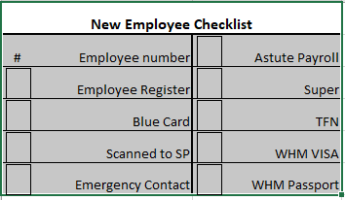
(OFFICE USE ONLY) START DATE: CLIENT: PAY CODE: EMPLOYEE NO:
Time Sheet Given - Book  Single Sheet 
INTERVIEW COMMENTS:

